THE EFFECTS OF POSITIVE AND NEGATIVE ENERGIES AND VIBRATIONS ON RICE

Have you ever thought of the effects that your thought processes can have on different things and people? Thought processes have the capability to change the environment. Your thought processes can be strong enough to make things rot and get mouldy as well. Thought processes are also called vibrations. Well under thought processes there are positive and negative vibrations. These negative and positive vibrations have drastic effects on the surrounding environment.
Doctor Emoto is a Japanese scientist who has done various experiments- effect of vibrations on water, and also the rice experiment which I am doing. He has discovered that negative and positive thoughts can change the states of objects like rice. In Dr Emoto’s water crystal experiment he took two glasses of water and labelled it with GOOD and BAD, and kept it in a public area. People passing by looked at the glasses of water and had different thought processes. After a few days Dr Emoto checked the formation of water crystals under a microscope and, the water had drastic changes. The water labelled GOOD had beautifully formed crystals whereas the crystals in the glass labelled BAD had deformed crystals. This experiment is helpful to mankind as it makes us realise the strength of our thoughts and how they can change the world. It tells us how we can practically solve all the problems in today’s life. Water pollution and many such problems can be solved by our positive thoughts. It reminds us of our capabilities, reminds us that there is no end to our potential. This very experiment can be used to grow crops which are free of germs because our positive thoughts can enhance the growth of the crops also. Since the water experiment using microscopes would be too complicated I am going to do the rice experiment as rice is made mostly of water.
For my science fair experiment I am going to keep six bowls containing the same rice in equal amounts of rice. The rice bowls would be labelled with three good values- Peace, Good and Happy and three bad values- Irritating, Greedy and Bad. I will keep these bowls in a public area. In this case I am keeping it in my school’s Library, Classroom and Art room. I am expecting the bowls with good values to stay fresher than the ones on which the values are written. This hypothesis is made from the background research given above.
BIBLIOGRAPHY
- http://www.csicop.org/specialarticles/show/a_grain_of_truth_recreating_dr._emotos_rice_experiment/
- http://themindunleashed.org/2014/01/scientific-proof-thoughts-intentions-can-alter-physical-world-around-us.html
- http://www.sageage.net/PDF/Articles/Emoto.pdf
Rice which was labelled with good: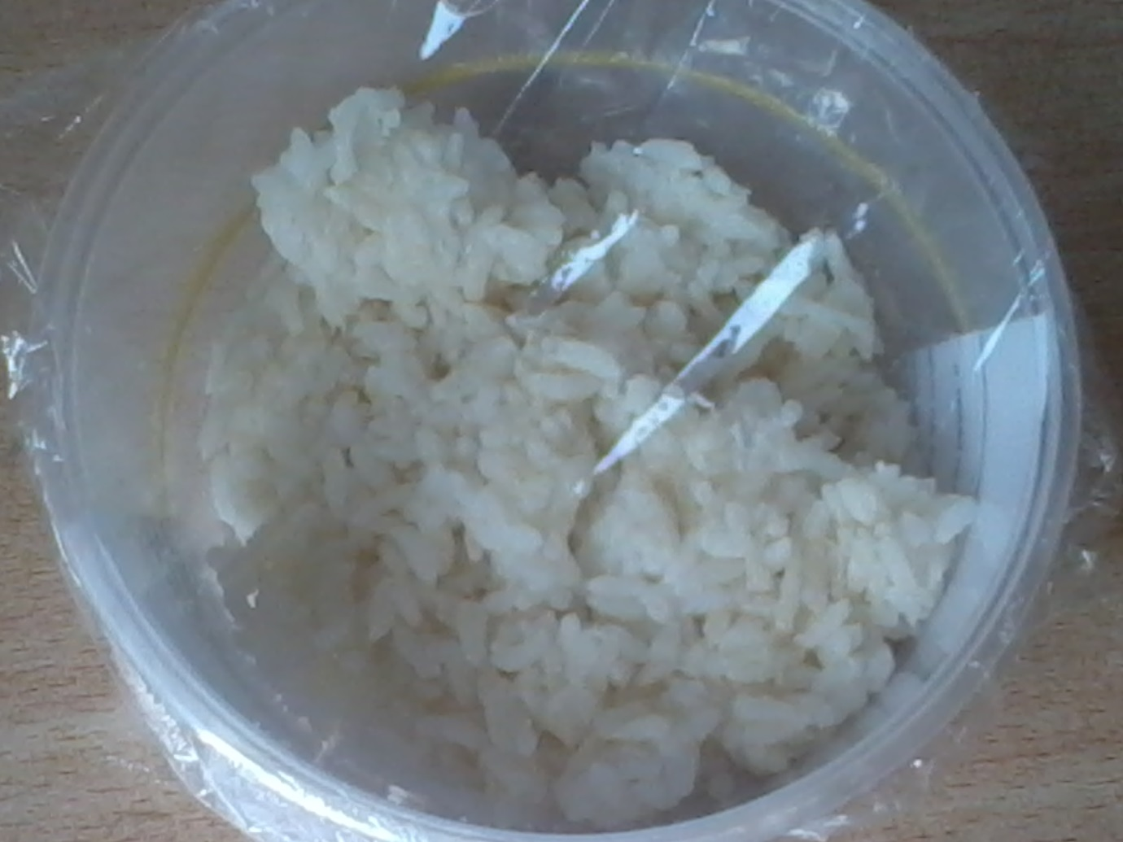
Rice which was labelled with Bad: